# Required Components.

**8**

|  |  |
| --- | --- |
|  #4 x 1 (100 Pack) Stainless Steel Phillips Pan Head Wood Screws, Stainless  Steel 304 (18-8), Pan Head Sheet Metal Screws Self Tapping for Wood: ...  **3**  **7**  **5**  **2**  **4**  **6**  **1** | **BOM**   1. Electric Water Gun 2. Water Container 3. Water Gun Stand 4. A Button 5. Velcro 6. Screws 7. Screw Driver 8. Mono Jack Cable |

# Required Tools

* Screwdriver

# Required Personal Protective Equipment (PPE)

* Safety Glasses

# Sources For Images (Due to not having the water gun available at the moment)

* The Elastic Cloth Tie Straps image is from amazon.com
* The Mono Jack Cable is from walmart.com

# Assembly Instructions

## Step 1

Remove 10 screws from the side of the water gun as pictured.

|  |
| --- |
|  |

## Step 2

Remove and set aside the half of the water gun that was held down by the screws. In this step, you should have the ten screws set aside.

|  |
| --- |
|  |

## Step 3

Remove any other screws that are holding down the battery. Before installing the jack, drill or cut a small hole at the left side of the water gun to fit the input jack. There is an image below to see the hole placement on the water gun.

Once removed and a hole is prepared, begin rewiring and solders them to the two legs of the input jack that you install at the back of the water gun. Then, solder the other ends of the wires to the two mono jack legs near the nut of the jack. This setup will be later placed in between the batteries of the device to allow for the assistive switch in this case the button to be used instead of the trigger on the gun. This allows the wiring to connect to an external button input that would help control the trigger mechanism inside of the gun.

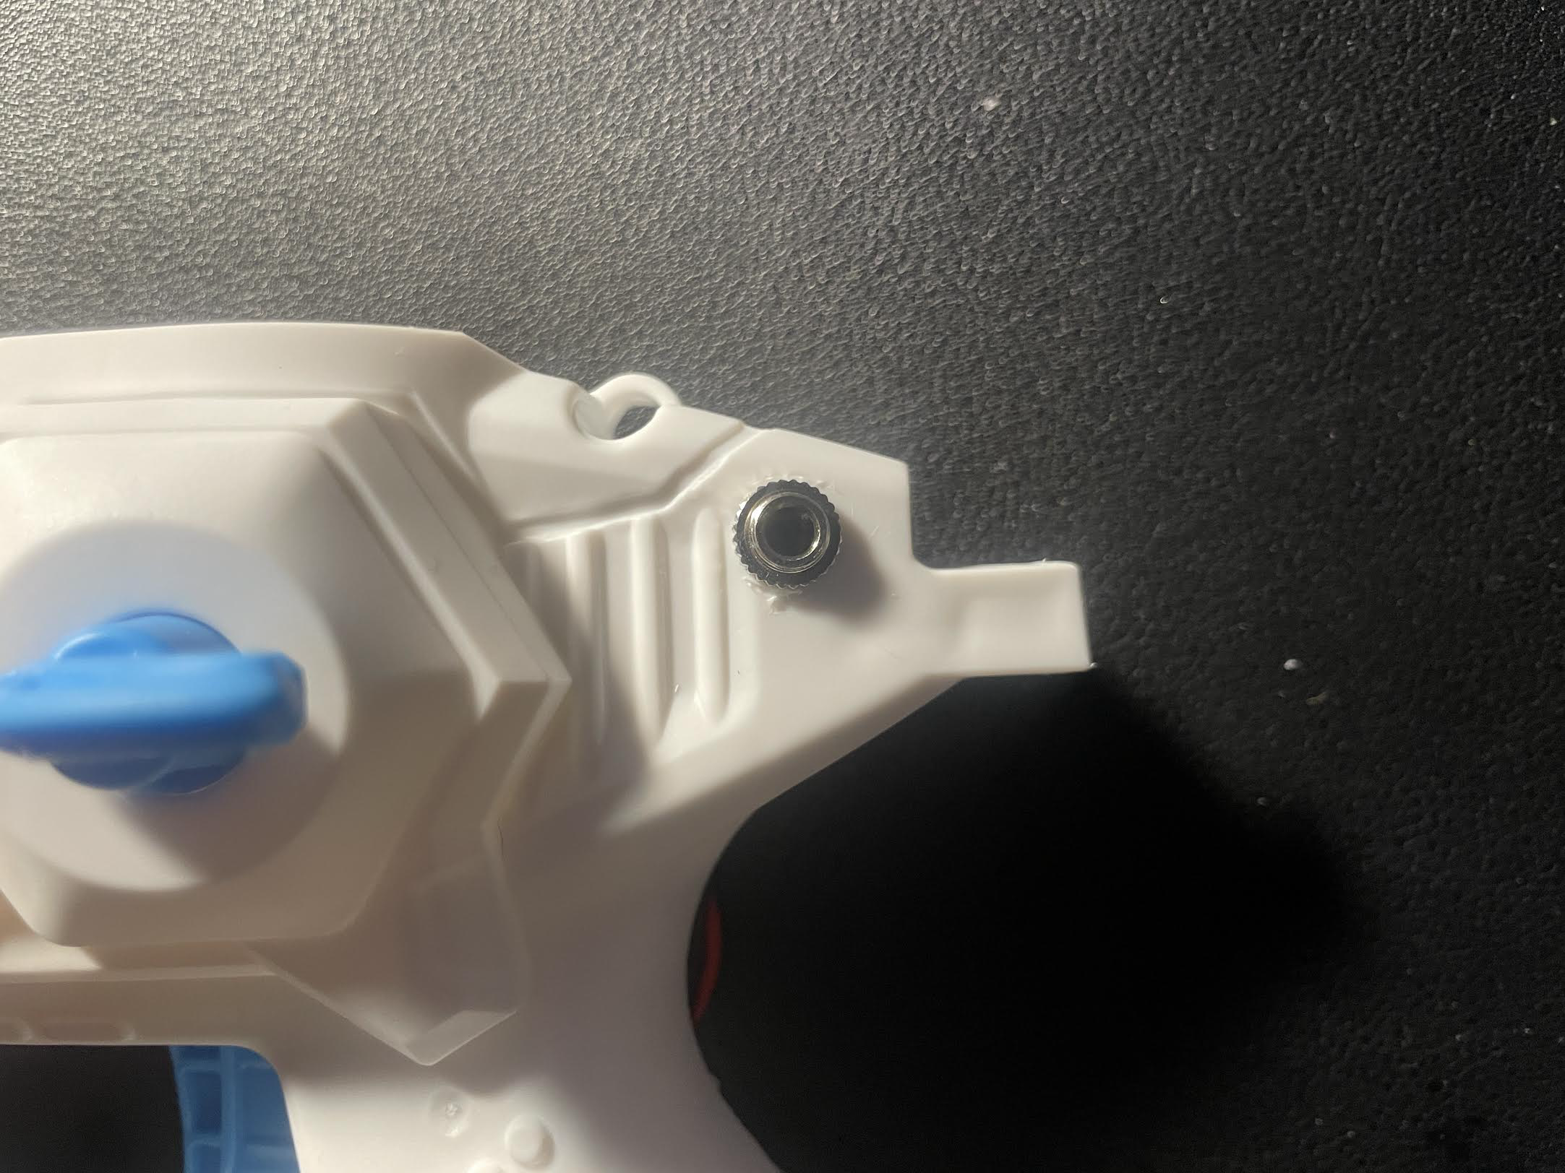

|  |
| --- |
| Close-up of hands working on a device  AI-generated content may be incorrect.  z |

## Step 4

Begin to reassemble the water gun by placing all parts back together and begin screwing the 10 screws into their designated areas.

|  |
| --- |
|  |

## Step 5

Once you have created two successfully designed buttons, begin to solder the button trigger and attach this trigger to a cable. This cable will be used to fire the water gun when clicked.

|  |
| --- |
|  |

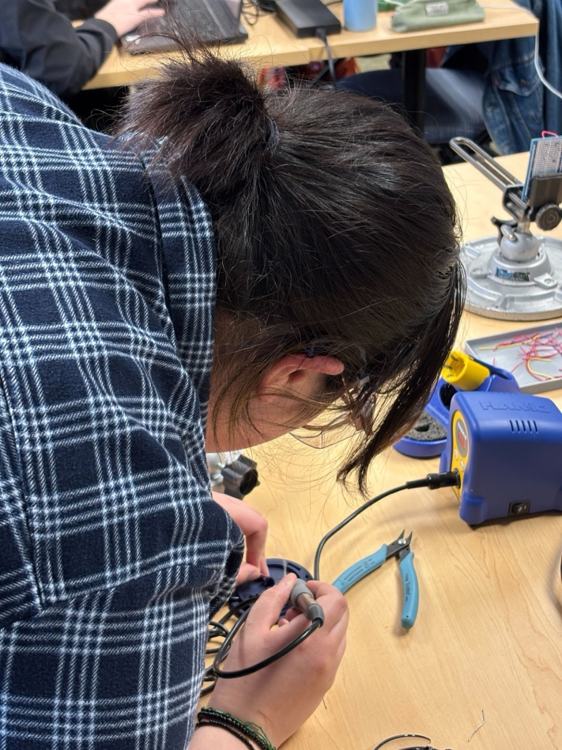

## Step 6

Connect the cable from the water gun to the external button and activate the water gun using the button. If the water gun does not shoot water, reattempt steps 1 through 6 and ensure that there is a clear connection between the trigger, the battery, the input port, and button.

|  |
| --- |
|  |

## Step 7

Now that there is a clear connection between the assistive device and the water gun, begin designing your water gun support on tinkercad. To create a water gun support, measure the distance of the jaw of your water gun. Be sure to account for the width of the padding on the water gun support and ensure that it can hold the water gun in place. First, print only the part of the water gun support that holds the gun itself, not the entire foundation—to test the fit before completing a full 3D print.

|  |
| --- |
|  |

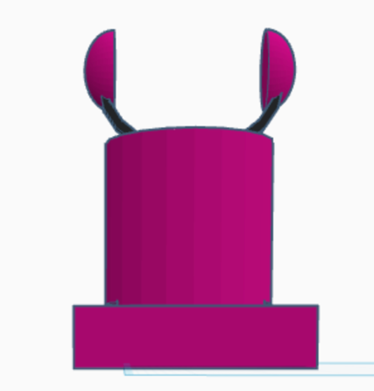 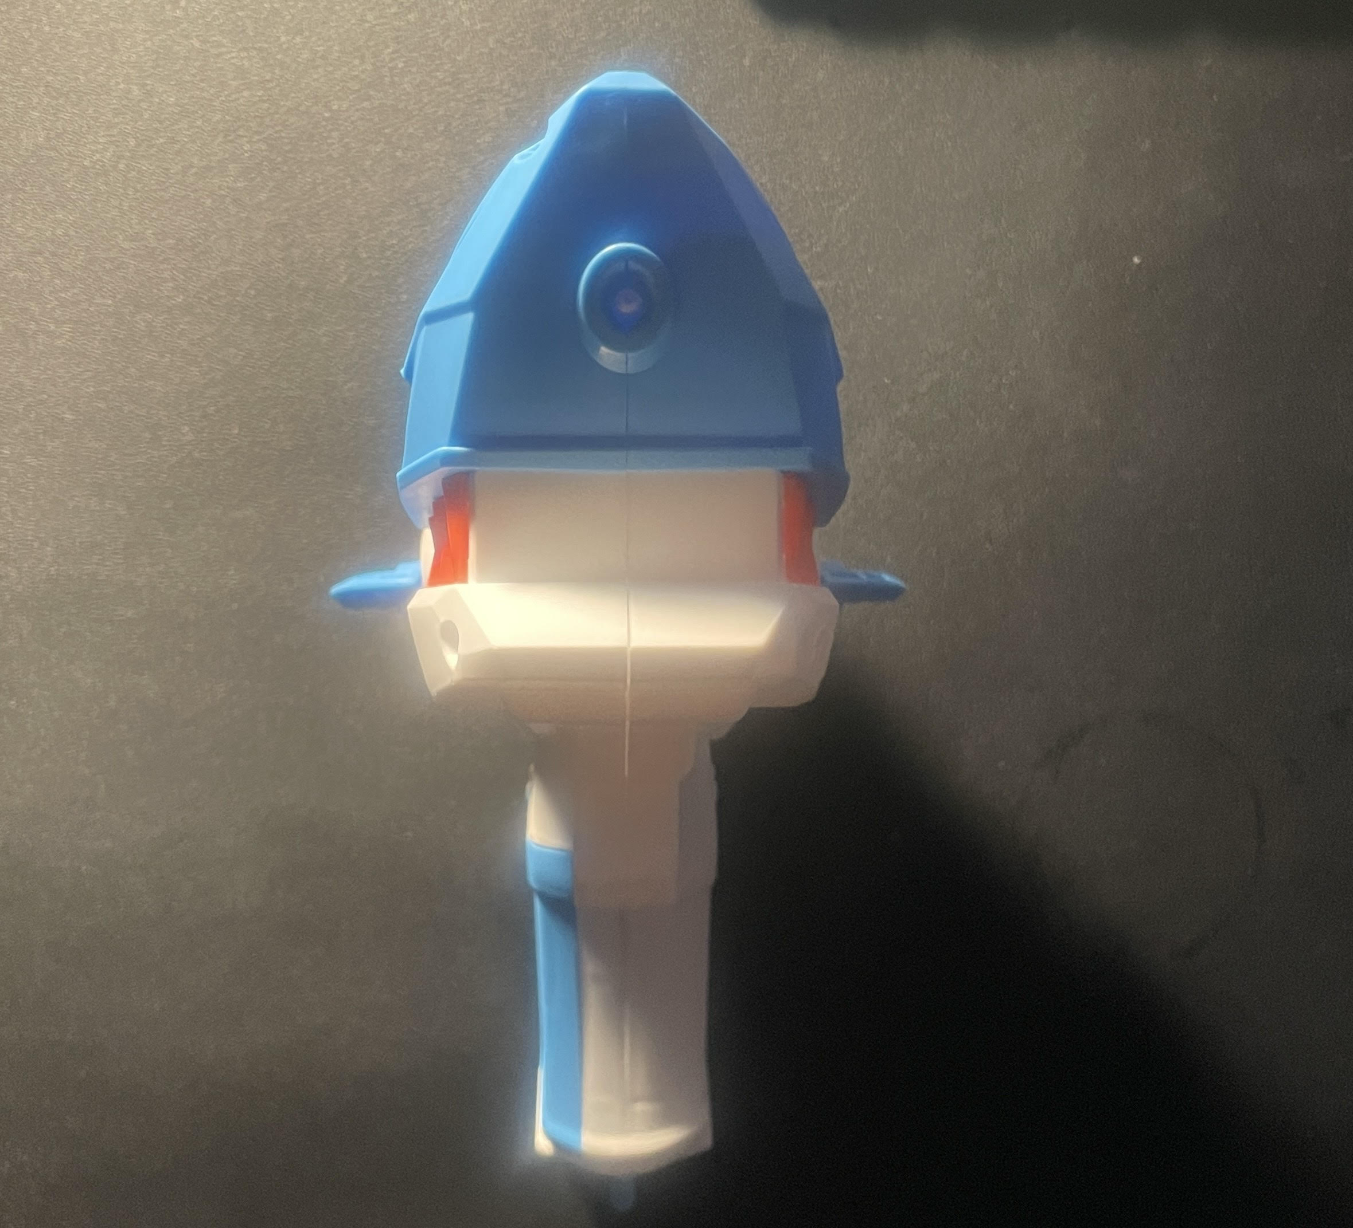

## Step 8

Once you have completed a 3D print of the water gun support, begin to create the arm strap that will be used to hold the water gun support in place on either a chair arm or an individual’s arm. You can use a Velcro to keep the arm strap securely in place. Make sure that the length of the arm straps accounts for varying chair arms and varying individual arm lengths. Ensure that these arm straps can fit through the water gun support.

|  |
| --- |
|  |

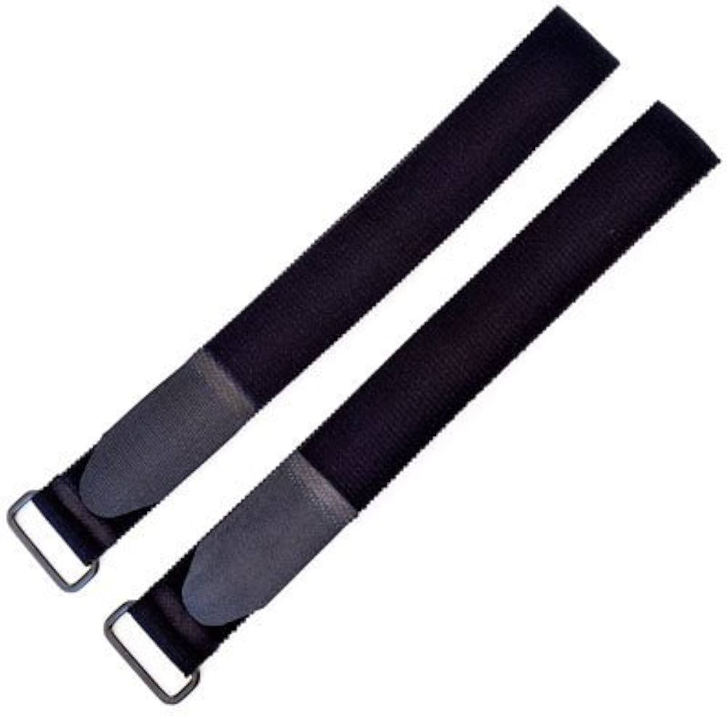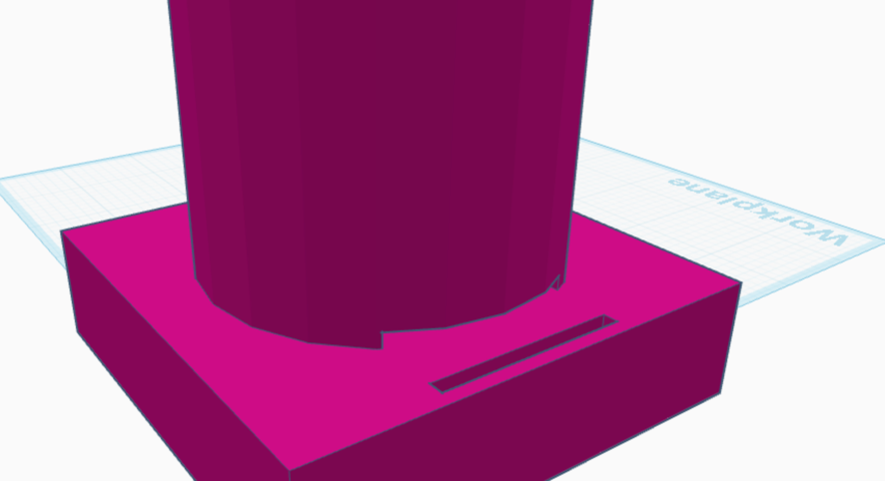

## Step 9

Place the gun on the water gun support and wrap the arm strap around the foundation and around your arm. Make sure that the water gun support rests comfortably on your arm. Once you have completed Step 10, you have created the water gun with a water gun support and two assistive switches.